**Mechatronics (19EMEC202) Course Project**

**Doc1: Team Members with Problem Statement**

Class: 4TH Sem ‘B’ div

Team number:

Details of Team Members:

|  |  |  |  |  |
| --- | --- | --- | --- | --- |
| Sl. No | Name | Roll No | SRN | Signature |
| 1 | VASUDEV. N. | 203 | 01FE20BME125 |  |
| 2 | ROHIT. V | 205 | 01FE20BME133 |  |
| 3 | ADITYA. D | 2 | 01FE20BME138 |  |
| 4 | SOURABH. P | 211 | 01FE20BME135 |  |
| 5 | NANDISH. A | 218 | 01FE20BME076 |  |
| 6 |  |  |  |  |
| 7 |  |  |  |  |

# Project Title:

# IoT Smart Agriculture & Automatic Irrigation System with ESP8266

**Project Statement**:

In this project, we will learn about the IoT Based **Smart Agriculture** & **Automatic Irrigation System** with **Nodemcu ESP8266**. Agriculture plays a vital role in the development of agricultural countries. Some issues concerning agriculture have been always hindering the development of the country. Consequently, the only solution to this problem is **smart agriculture** by modernizing the current traditional methods of agriculture. This would make irrigation smart and efficient by inclusion of technology.

**Inputs**:

**NodeMCU - ESP8266 12E board**

**Soil Moisture Sensor - Capacitive Soil Moisture V1.2**

**Oled Display - 0.96 I2C**

**DHT11 Sensor - (Humidity & temp Sensor)**

**Relay Module - 5V Relay Module**

**DC Motor Pump - 5V Water Pump**

**Breadboard**

**Connecting Wires - Jumper Wires**

**Outputs**:

This method is making agriculture smart using **automation** and **IoT technologies**. Internet of Things (IoT) enables various applications of **crop growth monitoring** and selection, **automatic irrigation** decision support, etc. We proposed **ESP8266 IoT Automatic irrigation system** to modernize and improve the productivity of the crop.

**System Function**:

In IoT based smart agriculture, a system is formed to monitor the farmland with the help of sensors, which senses components like temperature, light, humidity, soil moisture, etc. Then, automate the irrigation system and allow farmers to monitor their field conditions from anywhere through IoT Analytics Platform. To make the agricultural process even smarter and accurate, precision agriculture is used. This makes agricultural practice more controlled and precise in terms of raising livestock and farming. IoT based Smart Farming plays a vital role when it comes to the use of IT and other elements like sensors, agricultural drones, autonomous vehicles, control systems, automated hardware, robotics, variable speed technology, and others.

Block Diagram: -

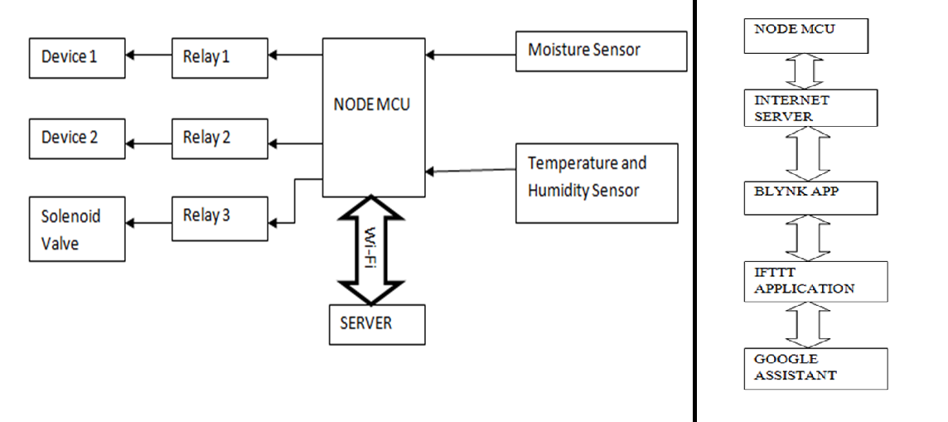

Faculty Sign